**Start with R**

For this assignment, you need to present the results, the code you used to answer a few questions, and then take a screenshot of your working environment.

Submit a textfile with typed up solutions here OR upload the document with solutions and the screenshot to your repository on Github and provide here only your Github URL. Make sure your homework files are clearly marked and readily findable there.

**1) Use R to figure out how many elements in the vector below are greater than 2.**

rooms <- c(1, 5, 2, 1, 3, 1, NA, 3, 1, 3, 2, 1, NA, 1, 8, 3, 1, 4, NA, 1, 3, 1, 2, 1, 7, 1, NA)

First, I enter the following: rooms <- c(1, 5, 2, 1, 3, 1, NA, 3, 1, 3, 2, 1, NA, 1, 8, 3, 1, 4, NA, 1, 3, 1, 2, 1, 7, 1, NA)

And press command enter.

I would like R to calculate and ignore the missing data therefore I type na.rm=TRUE

> stands for “greater than.”

Then I enter rooms>2 and press command enter

Script:

Console:

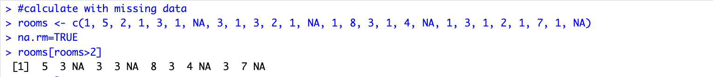

There are 9 elements in the vector, which are greater than 2

**2) Which function tells you the type of data the 'rooms' vector above contains?**

The function typeof(rooms) indicates the type of an object.

Script:



Console:



The type of date used for rooms is “double”

**3) What is the result of running the median() function on the above 'rooms' vector?**

By using the median() function you can calculate the median on the rooms vector

Script:

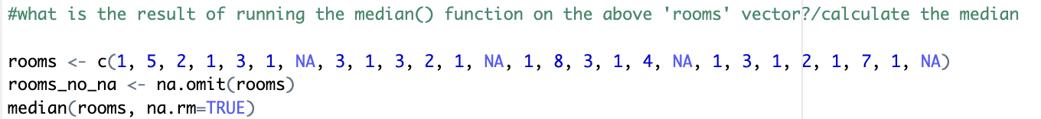

Console:

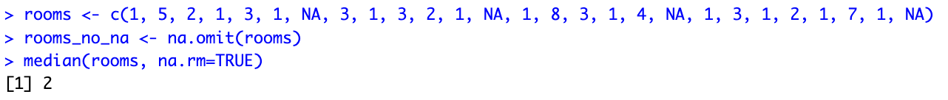

4) Submit the following image to Github: Inside your R Project (.Rproj), install the 'tidyverse' package and use the download.file() and read_csv() function to read the SAFI_clean.csv dataset into your R project as 'interviews' digital object (see instructions in https://datacarpentry.org/r-socialsci/setup.html and 'Starting with Data' section). Take a screenshot of your RStudio interface showing.

a) the line of code you used to create the object,

b) the 'interviews' object in the Environment, and

c) the file structure of your R project in the bottom right "Files" pane.

First we made a folder named “data” by typing dir.create(“data”)

Afterwards we downloaded the file SAFI_clean.csv and by typing data/ in front of the name, the file automatically downloaded into the data folder we just made.

Script:

Console:

Afterwards we typed library(tidyverse) and library(here)to load the packages.

Then we asked R to read our the downloaded data (SAFI_clean.csv) in our data folder as interviews by typing red_csv(). The “here” indicates for are where to find our data. We added na=”NULL” to indicate missing data as “na” instead of “NULL”

Script:

Console:

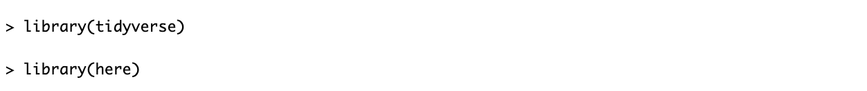

A picture of my Interviews:

A picture of my file structure in my R project (you can see the folder named “data”)

Save the screenshot as an image and put it in your AUID_lastname_firstname repository inside our Github organisation (github.com/Digital-Methods-HASS) or equivalent. Place here the URL leading to the screenshot in your repository.

There is screenshots in my GitHub repository, I have named them with numbers according to when they should be opened.

The link/URL to my Github repository: <https://github.com/TrineThestrup/au666121_Thestrup_Trine>